**A commentary on using extraction methods in data reduction analyses to assess social relationship structure in animals**

**F. Blake Mortona,b*, Drew Altschulb,c**

a Behaviour and Evolution Research Group, Psychology, School of Natural Sciences, University of Stirling, Stirling, U.K.

b Scottish Primate Research Group, U.K.

c Department of Psychology, The University of Edinburgh, Edinburgh, U.K.

**\*Correspondence:**

F.B. Morton, Psychology, School of Natural Sciences, University of Stirling, Stirling FK9 4LA, U.K. E-mail address: [morton.blake@gmail.com](mailto:morton.blake@gmail.com) (F. B. Morton).

**Keywords:** capuchin monkey, *Sapajus apella*, principal components analysis, factor analysis, Kaiser’s criterion, scree test, parallel analysis

**Introduction**

Comparative studies of social relationship structure (i.e. the number of dimensions and the characteristics of those dimensions) are critical to understanding animal sociality and how it evolves (refs). One challenge researchers face is how best to define and quantify social relationship structure such that the data are systematic and comparable across studies and taxa. Traditionally, social relationships have been described in terms of their affiliative behaviour (e.g. rates of grooming, spatial tolerance) and agonistic behaviour (e.g. rates of aggression) (Hinde 1976). More recently, Cords and Aureli (2000) proposed a 3-component model to define social relationship structure, including relationship ‘value’ (i.e. immediate benefits afforded by the relationship, such as grooming), ‘compatibility (i.e. tolerance based on partners’ shared history, such as tolerance at feeding sites), and ‘security’ (i.e. consistency and predictability in partners’ behaviour, such as rates of conflict).

Data reduction analyses like factor analysis (FA) and principal components analysis (PCA) identify inter-relationships between a set of potentially correlated variables, and cluster correlated variables into fewer discrete categories called “factors” (in FA) or “components” (in PCA) (Field 2009; Gorsuch, 1983). Because they can provide researchers with a systematic approach to categorizing different sets of behaviours (e.g. rates of grooming or aggression between group members), data reduction analyses are increasingly being used to describe social relationship structure in animals, such as Japanese macaques (*Macaca fuscata*; Majolo et al. 2010), Barbary macaques (*Macaca sylvanus*; McFarland and Majolo 2011), spider monkeys (*Ateles geoffroyi*; Rebeccini et al. 2011), capuchin monkeys (*Sapajus sp.,* formerly *Cebus apella*; see Alfaro et al. 2012; Morton et al. 2015), chimpanzees (*Pan troglodytes*; Fraser et al. 2008; Koski et al. 2012), bonobos (*Pan paniscus*; Stevens et al. 2015), and common ravens (*Corvus corax*; Fraser and Bugnyar 2010; Loretto et al. 2012). Although data reduction analyses have primarily been used to study primate social relationships, they illustrate why this approach is a potentially useful tool for studying social relationship structure across a much broader range of taxonomic groups (e.g. Fraser and Bugnyar 2010).

Before subjecting data to a data reduction analysis, one must first determine how many factors or components to extract from the analysis (Field 2009). This decision is critical given that it will influence how variables cluster together, thereby affecting the final solution (and hence) researchers’ interpretation of those results (Zwick and Velicer 1986; Ledesma and Valero-Mora 2007). Under-extraction can result in the loss of relevant information and distort the overall solution (Zwick and Velicer 1986). Over-extraction can result in some factors or components being unstable, making the overall solution difficult to interpret and/or replicate (Zwick and Velicer 1986).

Deciding when to stop extracting factors or components depends on when very little “random” variability remains in the final solution. Various cut-offs have been developed to help researchers make this decision, and involve calculating the amount of variation that is explained by each factor/component (called “eigenvalues”; Field 2009). Two commonly used methods are Kaiser’s criterion and Cattell’s scree test. Kaiser’s criterion retains components with eigenvalues >1.0; meaning, each component accounts for more variance than what is accounted for by one of the original variables (Kaiser 1960). Scree tests are a graphical technique that plots eigenvalues in a simple line plot. The number of components or factors to extract is visually estimated from the scree plot by finding the point where the line begins to level off; all components to the right of this point are considered random “noise” and should therefore be excluded (Cattell 1966).

Although each of these techniques is relatively simple to perform (perhaps contributing to their common usage by researchers), they can lead to spurious solutions. When factors/components are simple and strong, scree plots work quite well, but they are fundamentally subjective, and consequently lead to under- or over-extraction, particularly as the line of the plot begins to asymptote (Zwick and Velicer 1986). In simulations, scree tests are correct in only 41.7% of cases (Zwick and Velicer 1986). Thus, it is recommended that scree tests only be used alongside other methods.

While scree tests have maintained some utility over time, Kaiser’s criterion has not, a fact that has been known for some time (Revelle & Rocklin 1979). Whereas scree tests are subjective, Kaiser’s criterion is arbitrary: there is no empirical reason why a factor slightly greater than 1 ought to be retained while a factor with an eigenvalue just below 1 should not (Courtney 2013). Kaiser’s criterion has shown tendencies, depending on the circumstances toward over-extraction, and to a lesser degree under-extraction (Zwick and Velicer 1986). These biases are in part due to the observation that the number of components retained by the criterion more strongly reflects the number of variables included in the analysis than any attributes of underlying latent variables (Gorsuch 1983). In simulation, Kaiser’s criterion leads to a success rate of 8.77% and fails to extract the correct number of factors in more than 90% of cases (Ruscio & Roche 2012); yet, this criterion has remained the default for popular statistics software, such as IBM SPSS (Field, 2009).

In light of the deficiencies associated with scree tests and Kaiser’s criterion, many alternative methods have been developed, including Revelle & Rocklin’s (1979) Very Simple Structure (VSS), Standardized Root Mean Square Residuals (Hu & Bentler 1999) or SRMR, and the Bayesian Information Factor (Schwarz 1978) or BIC, to name a select few. Perhaps the most notable is Horn’s (1965) parallel analysis (PA), which has been widely used and tested, and is highly recommended by statisticians. The procedure is based on generating random eigenvalues that “parallel” the observed data in terms of sample size and the number of variables (Zwick and Velicer 1986). A factor/component is retained if its eigenvalue is greater than the 95th percentile of the distribution of eigenvalues generated from the random data (Horn 1965).

PA improves on other methods by taking into account sampling error, which is left unpartitioned from total variance in other methods (Horn, 1965). PA is not arbitrary: the “parallel” data it generates can be resampled from the empirical data themselves, and the technique is robust; both resampled and simulated parallel data do not yield substantively different results (Revelle 2015). Moreover, PA is flexible, having been modified and improved since its conception, and is capable of assessing factor and component structures, as well as both ratio and ordinal data (Garrido et al. 2012). Finally, PA is noteworthy when contrasted to other, modern factor number tests because unlike even the best alternatives, e.g. Comparison Data (Ruscio & Roche 2012), it is completely unbiased (cf. Courtney 2013, Table 1).

To date, most studies using data reduction analyses to describe the social relationship structure of animals have relied solely on Kaiser’s criterion (refs), with only a handful of studies supplementing this technique with a scree test (refs). All other methods are much less used, and PA is no exception (Morton et al. 2015; Stevens et al. 2015). Among these other tests, however, PA is unique in that it has survived and been improved upon since its invention (Horn 1965), and therefore remains unambiguously one of the best tests available.

Using data from a previous study of brown capuchin monkeys (*Sapajus sp.*) as an example (Morton et al. 2015), we illustrate how one’s choice of extraction method – specifically Kaiser’s criterion, a scree test, and parallel analysis – can differentially affect the results, and thus interpretation, of social relationship structure in animals.

**Methods and materials**

*Study site and subjects*

Eighteen brown capuchin monkeys were studied at the Living Links to Human Evolution Research Centre (LL), located within the Royal Zoological Society of Scotland (RZSS), U.K. (Macdonald and Whiten, 2011). Subjects were from two breeding groups. The ‘East’ group contained four adult males, three adult females, one juvenile male and five infants (following age–sex categories in Fragaszy et al. 2004). The ‘West’ group contained four adult males, three adult females, two juvenile males, one juvenile female and five infants. Infants dependent on their mothers (i.e. those less than a year old) were not included as study subjects. Subjects’ ages ranged from 2 to 40 years for males (mean ± SD = 10.79 ± 8.55 years, *N* = 11) and 3 to 14 years for females (mean ± SD = 8.86 ± 3.63 years, *N* = 7). All group members were captive born except an adult male from East group, who was hand-reared, and the original wild-caught alpha male of West group; both individuals came to LL as established members of their groups. Both breeding groups were housed separately in identically designed 189 m3 indoor enclosures with natural light and near-permanent access to a 900 m2 outdoor enclosure containing trees and other vegetation, providing ample opportunity to engage in natural behaviours. All monkeys received commercial TrioMunch pellets supplemented with fresh fruits and vegetables three times daily and were given cooked chicken and hardboiled eggs once a week. Water was available *ad libitum* at all times. Further details of housing and husbandry are provided in Leonardi et al. (2010).

*Ethical note*

This study was entirely observational except for one aspect of data collection involving puzzle feeders, which were placed within the monkeys’ outdoor enclosures (see ‘Behavioural sampling’). Subjects could interact freely with the puzzle feeders, which were made entirely of non-hazardous material. The feeders provided a source of food snacks (raisins) and enrichment to subjects. This study was approved by Edinburgh Zoo and the ethics committee of the Psychology Department at the University of Stirling, and complied with the ASAB (2012) Guidelines.

*Behavioural sampling*

Behavioural data come from a previous study by Morton et al. (2015). Fifty-four hours of focal observations were recorded between May and August of 2011, totalling 3 h per individual. Behaviours (Table 1) were recorded daily per focal monkey for 10 min. Monkeys were sampled evenly between 0900 and 1730 hours. Incidences of aggression, coalitions, scrounging and food sharing were recorded continuously; all other behaviours were recorded at 1 min intervals using point sampling (Martin and Bateson 2007). In each point sample, group members within two body lengths from the focal were recorded. The total number of sampling points was the same for all subjects.

Between 15 May 2011 and 8 June 2011 five puzzle feeders were introduced to the outdoor enclosures of each group. Monkeys could freely interact with the feeders. Each feeder was made out of a cylindrical piece of white piping (length: 76.2 cm; diameter: 5.08 cm), with approximately 8–10 holes drilled into it (see Appendix Fig. A1 in Morton et al., 2015). Feeders were attached vertically to trees, 2–10 m apart. For each feeder, the bottom of the pipe was left open while the top of the pipe was closed. Ten paper packets, each containing five raisins, were placed in the top portion of each feeder, and wooden sticks were inserted into the holes of the pipes to prevent the packets from falling out from the bottom. The packets dropped freely from the pipe once all the wooden sticks had been removed by the monkeys. Feeders were introduced 4 days a week for approximately 30 min each day or until all of the puzzle feeders had been solved. During sessions, all instances in which a monkey approached another monkey at a feeding site were recorded, as well as the behavioural response of the receiving monkey (i.e. by avoiding or staying). East group underwent 8 sessions and West group underwent 10 sessions.

Following previous studies of study social relationship structure (e.g. Rebeccini et al. 2011; Koski et al. 2012), a set of behavioural measures (Table 1) were calculated as events per monkey dyad and subjected to a principal components analysis (PCA) with varimax rotation. Overall mean numbers of social dyadic interactions are provided in Appendix Table A1 in Morton et al. (2015).

*Statistical analyses*

All analyses were conducted in the R programming language, using the psych package (Revelle 2015). The “nfactors” function of the psych package produces a variety of preliminary statistics and an accompanying descriptive chart (Figure 1), which includes VSS, Complexity, SRMR, and empirical BIC. These statistics are popular, well-documented, and useful for comparisons to other tests, e.g. Kaiser’s criterion & PA; these two tests were visualized on a scree plot using a separate function – “fa.parallel”.

Following previous studies, component loadings greater than |0.4| were considered salient (e.g. Koski et al. 2012). Components with high loadings (i.e. |0.7|) and/or those with four or more loadings greater than |0.4| were considered robust (Guadagnoli and Velicer 1988). Seventy-three dyads and 10 behavioural measures were entered into each PCA, which meets previous recommendations for having a fixed ratio of at least 5 between the sample size and number of variables (Gorsuch 1983). Components with high loadings (i.e. |0.7|) and/or those with four or more loadings greater than |0.4| were considered robust (Guadagnoli and Velicer 1988). The 3 component PCA solution comes from Morton et al. (2015).

**Results**

*Determining the number of factors or components*

A variety of methods can and should be used to determine the number of factors/components to extract since few datasets yield an immediate and clear solution. The results of our call to the “nfactors” function are shown in Figure 1. Some of the statistics produced by “nfactors” can and will be inconclusive, in this case, SRMR. SRMR indicates that any solution with a value under 0.1 is acceptable, so for these data it allows any solution of 2 factor/components or greater, and does not contradict either a 2 or 3 component structure.

Overall, 2 factors/components were the most supported. VSS examines how well the individual factors/components fit within many solutions, where each progressive solution has one more factor/component than the last (Revelle & Rocklin 1979). The sharp rise from 1 factor to 2 factors, and flattening out from 2 factors/components onwards, suggests that 2 factors are an appropriate number to extract. Complexity represents the average number of factors needed to account for the measured variables. In an ideal solution, each factor would have a complexity of 1, meaning that every variable loaded solely on a single factor in the solution (Hofmann 1978). Complexity similarly rises when a third factor is added, suggesting that 2 factors are a better fit than 3. The Empirical BIC, an information theoretical assessment of fit, also suggests that 2 factors are best fit since empirical BIC reaches a minimum with the 2-factor solution.

(Figure 2). As initially described by Horn (1965), parallel analysis was not appropriate for FA, only PCA. FA and PCA often produce very similar solutions in practice, but the underlying matrix algebra differs such that when each procedure is repeated, as in parallel analysis simulations, and the results can differ considerably. So while many tests need not distinguish between factors and components, parallel analysis must be adjusted to support FA (Revelle 2015). Since we chose to use PCA for data reduction, this is not an issue in the current analysis, but we wish to highlight the nuance of all such analyses.

Kaiser’s criterion suggested that 3 components ought to be extracted. In contrast, both the scree plot, VSS, Complexity, empirical BIC, and parallel analysis (Figure 2) suggest only 2 components should be retained in the solution (Morton et al. 2015). We extracted both 2 and 3 component solutions, and compared their fit and interpretability.

*Extracted Solutions*

The 3 component solution had eigenvalues over 1.0, and explained 67.32% of the total variance. The first component was moderately correlated with the second component (r=0.493), and weakly correlated with the third component (r=-0.106). The second component was weakly correlated with the third component (r=0.01). Component 1 (Table 2) had an eigenvalue of 2.56, explained 25.6% of the variance, and was characterized by moderate to high loadings (>0.4) by behaviours reflecting the importance of the relationship in terms of social affiliation (i.e. proximity, social foraging) and direct benefits gained from this affiliation (i.e. grooming, grooming symmetry, coalitions). Component 2 (Table 2) had an eigenvalue of 2.45, explained 24.48% of the variance, and was characterized by moderate to high loadings (>0.4) from behaviours related to tolerance to approaches (avoid-stay symmetry), tolerance at feeding sites (social foraging, food sharing, food sharing symmetry), and coalitionary support. Component 3 (Table 2) had an eigenvector of 1.72, explained 17.24% of the variance, and was characterized by high loadings (>0.89) from behaviours indicating a lack of stability or predictability in the relationship (i.e. conflict and conflict symmetry).

The 2 component solution collectively explained 55.0% of the total variance. Component 1 (Table 2) had an eigenvalue of 3.72, explained 37.22% of the variance, and was characterized by moderate to high loadings (>|0.45|) on behaviours related to social affiliation (e.g. proximity, social foraging, food sharing, and grooming). Component 2 (Table 2) had an eigenvalue of 1.78, explained 17.8% of the variance, and was characterized by high loadings (>|0.869|) from agonistic behaviours, i.e. conflict and conflict symmetry. Compared to the 3-component solution, correlations between these two components were only weakly correlated (r=-0.072).

To assess the internal consistency of the solutions, we applied ωh to both the 2 and 3 component solutions (Dunn et al. 2014). For the 2 component solution, ωh = 0.08, which suggests that there were no large effects left unaccounted for by missing latent variables (e.g. a third component, cf. Cords & Aureli 2000). On the other hand, for the 3 component model, ωh = 0.64. An ωh of this magnitude suggests that a single-level 3 component structure alone does not adequately model the data, and points towards there being an additional, general latent variable (e.g. a combination of two of the extracted constructs).

**Discussion**

The PCA solution derived using Kaiser’s criterion closely resembled the 3-component model proposed by Cords and Aureli (2000). Component 1 resembled relationship “value” (e.g. grooming and food sharing), component 2 resembled relationship “compatibility” (e.g. tolerance at feeding sites), and component 3 resembled relationship “security” (e.g. rates of aggression). By contrast, the PCA solution derived using a scree test and parallel analysis recommended two components, i.e. basic affiliative and agonistic components, which, as previously discussed, reflects a more traditional approach to describing social relationship structure (e.g. Hinde 1976).

Similar findings have recently been reported in bonobos by Stevens et al. (2015), who identified three components resembling the 3-component model proposed by Cords and Aureli (2000) when using Kaiser’s criterion and a scree test, but ended up retaining only two components (labelled ‘value’ and ‘compatibility’, respectively) based on a parallel analysis. Importantly, their findings also illustrate how a scree test, which in our current study recommended the same number of components as a PA, can be more liberal than the unbiased parallel analysis.

As previously noted, most studies have relied solely on Kaiser’s criterion to interpret and compare the social relationship structures of their animals. These studies, including the current study, typically find 3 components to subjects’ social relationships (but see Rebeccini et al. 2011). If one examines the individual loadings of the behavioural measures that are entered into each of these analyses (most of which are the same measures used across all of these studies), there are striking differences in terms of how certain items load onto each component. For example, in capuchins and Japanese macaques, aggression loads positively onto a component resembling relationship “security” (this study; Majolo et al. 2010), whereas in chimpanzees, Barbary macaques, and corvids, the same measure loads positively onto a component resembling relationship “compatibility” (Fraser et al. 2008; Fraser and Bugnyar 2010; Koski et al. 2012). Additionally, in capuchins and Japanese macaques, grooming symmetry loads positively onto a component resembling relationship “value” (this study; Majolo et al. 2010), whereas in chimpanzees and Barbary macaques, the same measure loads positively onto a component resembling relationship “security” (Fraser et al. 2008; McFarland and Majolo 2011).

Two possible explanations may underlie these differences. First, certain items like aggression and grooming symmetry may have different meanings for capuchin and Barbary macaque social relationships, which could explain why these behaviours cluster onto different components compared to solutions derived in other species. Alternatively, differences between studies may reflect instability in the PCA solutions derived using Kaiser’s criterion. This is not to say that using Kaiser’s criterion is “wrong” *per se*; rather, as noted previously, one major disadvantage to this approach is that it often leads to unstable solutions as a result of over-extraction (Fabrigar et al. 1999). In other words, it spreads the item loadings “too thin” across factors/components. Moreover, Kaiser’s criterion is easily susceptible to sampling error (Ruscio & Roche 2012). Thus, within the context of social relationship studies, while structural differences in item loadings across studies could be biologically meaningful (i.e. they could reflect differences in sociality), they could just as likely reflect structural instability brought about by sample variability.

Although scree tests are subjective, they can be useful when automated methods disagree on the number of factors/components to extract. In such cases, a scree test may be used as a “tie-breaker” if the plot reveals a clear and distinct drop in the eigenvalues past a certain factor/component. Alternatively, more sophisticated analyses like Everett’s tests (Everett 1988) could be used to aid decisions about extraction. Such instances are becoming increasingly rare as automated methods are improved upon, but the fact remains that scree tests should only be used alongside other, more robust and automated tests like PA and empirical BIC.

PA has a long, published record of success in multiple simulation studies (Zwick & Velicer 1986; Fabriger 1999; Ruscio & Roche 2012), but again, no single method should be blindly relied upon when deciding how many factors/components to extract. Rather, PA is a recommended starting point for researchers exploring their data in preparation for FA or PCA, because of its robustness, but also due to the ease with which it can be directly compared to the scree tests (Figure 2), and other objective methods (e.g. empirical BIC).

**Conclusion**

In light of the well-known deficiencies associated with Kaiser’s criterion, we recommend that researchers refrain from using this technique in future work on social relationship structure. Although we recommend a wider use of PA, all extraction methods have their drawbacks (Ruscio & Roche 2012). Therefore, as discussed, PA should not be the sole method used to determine how many components/factors to extract. Rather, this approach should be supplemented with other extraction techniques, such as scree tests or more robust automated tests (e.g. empirical BIC, VSS, Comparison Data). If different tests recommend different extraction numbers, then further analyses like Everett’s tests may be needed to aid in choosing between multiple possible models, post-extraction. Collectively, the current example should serve as a cautionary note to researchers wishing to use data reduction analyses to study social relationship structure in animals. In particular, careful decisions must be made when determining how many components or factors to retain in one’s analysis. Doing so will greatly improve the utility and reliability of data reduction techniques for comparative interpretations of animal social relationships.

**References**

Alfaro JWL, Silva JDSE, Rylands AB (2012) How different are robust and gracile

capuchin monkeys? An argument for the use of Sapajus and Cebus. American

Journal of Primatology, doi: 10/1002/ajp.22007.

ASAB (2012) Guidelines for the treatment of animals in behavioural research and

teaching. Animal Behaviour, 83:301-309.

Cattell RB (1966) The scree test for the number of factors. Multivariate Behavioural

Research, 1:245-276.

Cords M, Aureli F (2000) Reconciliation and relationship qualities. In: Natural conflict

resolution (Aureli F. & de Waal F.B.M., eds.). University of California Press,

Berkley, CA, p. 177-198.

Courtney, M. G. R. (2013). Determining the number of factors to retain in EFA: Using the SPSS R-Menu v2. 0 to make more judicious estimations. Practical Assessment, Research & Evaluation, 18(8), 1-14.

Dunn, T. J., Baguley, T., & Brunsden, V. (2014). From alpha to omega: A practical solution to the pervasive problem of internal consistency estimation. British Journal of Psychology, 105(3), 399-412.

Everett, J. E. (1983). Factor comparability as a means of determining the number of factors and their rotation. Multivariate Behavioral Research, 18(2), 197-218.

Fabrigar, L. R., Wegener, D. T., MacCallum, R. C., & Strahan, E. J. (1999). Evaluating the use of exploratory factor analysis in psychological research. Psychological methods, 4(3), 272.

Field A (2009) Discovering statistics using SPSS, third ed. London, SAGE.

Fragaszy DM, Visalberghi E, Fedigan LM (2004) The complete capuchin. Cambridge:

Cambridge University Press.

Fraser ON, Bugnyar T (2010) The quality of social relationships in ravens. Animal

Behaviour, 79:927-933.

Fraser ON, Schino G, Aureli F (2008) Components of relationship quality in

chimpanzees. Ethology, 114:834-843.

Garrido, L. E., Abad, F. J., & Ponsoda, V. (2013). A new look at Horn’s parallel analysis with ordinal variables. Psychological methods, 18(4), 454.

Gorsuch RL (1983) Factor analysis, 2nd Edition. Hillsdale, NJ:LEA.

Gouadagnoli E, Velicer WF (1988) Relation of sample size to the stability of component

patterns. Psychological Bulletin, 103:265-275.

Hinde RA (1976) Interactions, relationshipos, and social structure. Man, 11:1-17.

Hofmann, R. J. (1978). Complexity and simplicity as objective indices descriptive of factor solutions. Multivariate Behavioral Research, 13(2), 247-250.

Horn JL (1965) A rationale and test for the number of factors in factor analysis. Psychometrika,

30:179-185.

Hu, L. T., & Bentler, P. M. (1999). Cutoff criteria for fit indexes in covariance structure analysis: Conventional criteria versus new alternatives. Structural equation modeling: a multidisciplinary journal, 6(1), 1-55.

Kaiser HF (1960) The application of electronic computers to factor analysis. Ed. Psychol. Meas.,

20:141-151.

Koski SE, de Vries H, van de Kraats A, Sterck EHM (2012) Stability and change of social

relationship quality in captive chimpanzees. International Journal of Primatology, 33:905-

921.

Ledesma RD, Valeromora P (2007) Determining the number of factors to retain in EFA: an easy-

to-use computer program for carrying out parallel analysis. Practical Assessment,

Research & Evaluation, 12:1-11.

Leonardi, R., Buchanan-Smith, H. M., Dufour, V., MacDonald, C., & Whiten, A. (2010). Living together: Behavior and welfare in single and mixed species groups of capuchin (*Cebus apella*) and squirrel monkeys (*Saimiri sciureus*). *American Journal of Primatology*, *72*, 33–47.

Loretto, M.-C., Fraser, O. N., & Bugnyar, T. (2012). Ontogeny of social relations and coalition formation in common ravens (*Corvus corax*). *International Journal of Comparative Psychology*, *25*, 180–194.

Macdonald, C., & Whiten, A. (2011). The ‘Living Links to Human Evolution’ research centre in Edinburgh zoo: A new endeavour in collaboration. *International Zoo Yearbook*, *45*, 7–17.

Majolo, B., Ventura, R., & Schino, G. (2010). Asymmetry and dimensions of relationship quality in the japanese macaque (*Macaca fuscata yakui*). *International Journal of Primatology*, *31*, 736–750.

Martin, P., Bateson, P. (2007). Measuring behaviour: an introductory guide. Cambridge,

U.K.: Cambridge University Press.

McFarland, R., & Majolo, B. (2011). Exploring the components, asymmetry and distribution of relationship quality in wild barbary macaques (*Macaca sylvanus*). *PLoS One*, *6*, e28826.

Morton FB, Weiss A, Buchanan-Smith HM, Lee PC (2015) Capuchin monkeys with similar personalities have higher-quality relationships independent of age, sex, kinship, and rank. *Animal Behaviour*. Doi: 10.1016/j.anbehav.2015.04.013

Rebecchini, L., Schaffner, C. M., & Aureli, F. (2011). Risk is a component of social relationships in spider monkeys. *Ethology*, *117*, 691–699.

Revelle, W., & Rocklin, T. (1979). Very simple structure: An alternative procedure for estimating the optimal number of interpretable factors. Multivariate Behavioral Research, 14(4), 403-414.

Revelle, W. (2015) psych: Procedures for Personality and Psychological Research, Northwestern University, Evanston, Illinois, USA, http://CRAN.R-project.org/package=psych Version = 1.5.4.

Ruscio, J., & Roche, B. (2012). Determining the number of factors to retain in an exploratory factor analysis using comparison data of known factorial structure. Psychological assessment, 24(2), 282.

Schwarz, G. (1978). Estimating the dimension of a model. The annals of statistics, 6(2), 461-464.

Stevens JMG, de Groot E, Staes N (2015) Relationship quality in captive bonobo

groups. Behaviour, 152:259-283.

Zwick WR, Velicer WF (1986) Comparison of five rules for determining the number of

components to retain. Psychological Bulletin, 99: 432-442.

Table 1. Behavioural measures calculated for each monkey dyad (reproduced with permission from Morton et al. 2015). *

|  |  |
| --- | --- |
| **Behavioural measure** | **Calculation** |
| Avoid/Stay Symmetry | (no. times A approaches B) / [(no. times A approaches B) + (no. times B approaches A)] |
| Coalitions | [(no. times A supports B) + (no. times B supports A)] |
| Conflict | [(no. times A aggresses B) + (no. times B aggresses A)] |
| Conflict Symmetry | (no. times A aggresses B) / [(no. times A aggresses B) + (no. times B aggresses A)] |
| Food Sharing | [(no. times A gives to B) + (no. times B gives to A)] |
| Food Sharing Symmetry | (no. times A gives to B / [(no. times A gives to B) + (no. times B gives to A)] |
| Grooming | [(no. minutes A grooms B) + (no. minutes B grooms A)] |
| Grooming Symmetry | (no. minutes A grooms B) / [(no. minutes A grooms B) + (no. minutes B grooms A)] |
| Social Foraging | [(% of time A within proximity of B) + (% of time B within proximity of A)] |
| Spatial Proximity | [(% of time A within proximity of B) + (% of time B within proximity of A)]** |

*Modified from Rebecchini et al. (2011) and Koski et al. (2012). **These calculations do not include time spent grooming or time spent social foraging.

Table 2. Varimax-rotated PCA structure of 10 behavioural measures based on Kaiser’s criterion, a scree test, and parallel analysisa

|  |  |  |  |  |  |  |
| --- | --- | --- | --- | --- | --- | --- |
| Behavioural measure | Kaiser’s criterion | | |  | Parallel analysisb,c | |
| PC1 | PC2 | PC3 |  | PC1 | PC2 |
| Spatial Proximity | **.863** | .274 | .028 |  | **.803** | -.112 |
| Grooming | **.806** | .285 | .050 |  | **.772** | -.077 |
| Grooming Symmetry | **-.743** | .099 | .168 |  | **-.450** | .343 |
| Avoid/Stay Symmetry | .048 | **-.763** | -.036 |  | **-.507** | -.188 |
| Food Sharing | .247 | **.680** | -.202 |  | **.651** | -.120 |
| Food Sharing Symmetry | .088 | **.658** | .175 |  | **.532** | .272 |
| Coalitions | **.434** | **.658** | -.064 |  | **.771** | -.033 |
| Social Foraging | **.590** | **.607** | -.011 |  | **.846** | -.026 |
| Conflict Symmetry | .006 | .033 | **.899** |  | .049 | **.865** |
| Conflict | -.086 | -.019 | **.898** |  | -.053 | **.875** |

aSalient loadings (>|0.4|) per behaviour are in bold; PC=principal component; bA scree test, complexity, empirical BIC, and VSS also recommended that two components be extracted; c reproduced with permission from Morton et al. (2015).

Figure 1. Plotted result of the R psych package “nfactors” function.

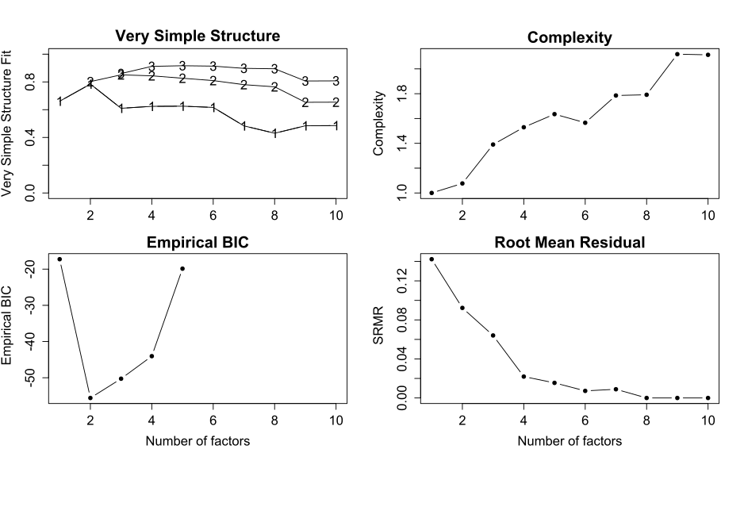

a

a The number of variables (10) limits the calculation of empirical BIC to solutions of at most 5 factors.

Figure 2. Results of parallel analysis, on a scree plot.

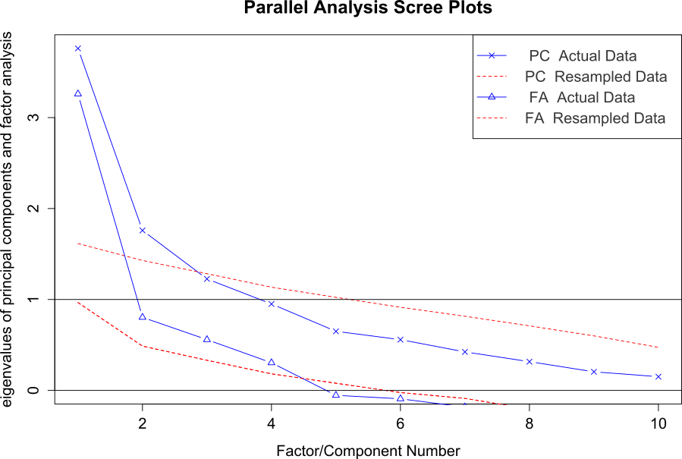

*Note.* Triangles indicate eigenvalues for components; X’s indicate adjusted eigenvalues for factors. Dashed lines represent random simulated eigenvalues for the corresponding factor or component procedures. The horizontal black lines are the Kaiser’s criterion (for PCA, at 1) and adjusted criterion (for FA, at 0).